SYNTHESIS OF IN-CHAIN MULTI-FUNCTIONALIZED SYNTHETIC RUBBERS

Liao Shuang-quan1,Wang Zhi-fen1, She Xiao-dong1, Li Si-dong2, Zhong Jie-ping2
1. College of Materials and Chemical Engineering, Hainan University, Haikou 570228, China
2. College of Science, Guangdong Ocean University, Zhanjiang 524088, P. R. China
E-mail address of the presenting author(shqliao@263.net)

Abstract:

Functionalization of matrix polymer is an attractive approach for improving the dispersity of carbon black (CB) especially in rubber-based composites, i.e., to introduce functional groups such as epoxy and carboxyl groups directly into rubber backbone to interact with the functional groups present on the CB surface. Better compatibility between CB and rubber matrix could be achieved only upon application of high temperature molding or high temperature extrusion in the presence of silane coupling agent.

However, few studies have been focused on the functionalization of matrix rubber by introducing multiple dimethylamino groups along the rubber backbone. These rubber-based composites containing finely dispersed CB could be applied particularly to tire tread rubber of green tire from the standpoint of running safety and fuel consumption. The number of dimethylamino groups along the random butadiene-styrene copolymer backbone is definitely controlled by the monomer feed ratio and polymer molecular weight.

SEM observations revealed great improvement in terms of CB dispersion in such dimethylamino in-chain multi-functionalized rubber matrix. This provides an effective route to prepare rubber-based composites with good CB dispersion, which have potential applications in rubber reinforcement, bitumen binders, CB-filled elastomers and high-performance automotive tires and other advanced materials.

Keywords: matrix polymer; green tire

Acknowledgements
National Natural Science Foundation of China (21034001) and National Key Technologies R&D Program of China (2013BAH03B01).

References
[1]L. Jong, J. Appl. Polym. Sci., 2008, 108, 65-75
[2] Lingling Wu, Yanshai Wang, Yurong Wang, Kaihua Shen, Yang Li，Polymer，2013, 54, 2958-2965
[3] Lingling Wu，Hongwei Ma，Xinyi Lu，Yanshai Wang，Yurong Wang，Yang Li，J. Macro. Sci. A, Pure and Appl. Chem.，2013, 51, 27-32
[4] Bai Wang, Hongwei Ma, Yanshai Wang, Yang Li，Chem. Lett.，2013, 42(8), 915-9174
[5] Bai Wang，Hongwei Ma，Kaihua Shen，Ding Jun，Yang Li，Chin. Chem. Lett.，2012, 23, 1419-1422
[6]

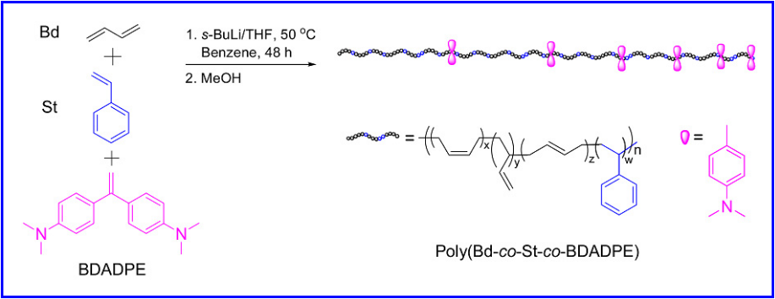

Figure 1. Synthesis of in-chain multi-functionalized random butadiene-styrene copolymer using BDADPE as comonomer.

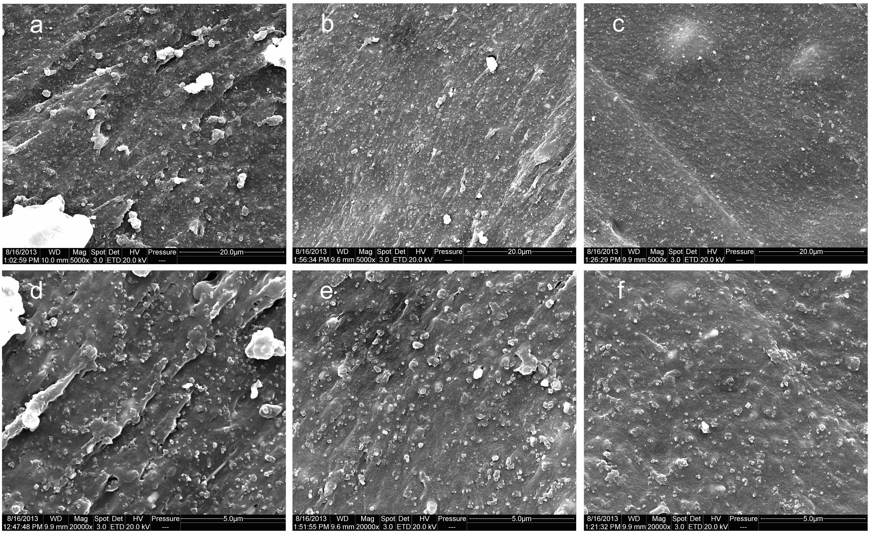
Figure 2. SEM micrographs of fracture surface of in-chain multi-functionalized random butadiene-styrene copolymer vulcanizates filled with 50 phr of CB and the molar content of BDADPE unit: 0 for Composite 1 (a and d), 0.2% for Composite 2 (b and e) and 1.1% for Composite 3 (c and f).

