Abstract Title (14-point Times New Roman, boldface type, centered relative, and initially capitalized)

First Name Last (Surname) Name¹ and First Name Last (Surname) name^{2*}
(Example: Joana Magalhaes¹, Rui Sousa ², 12-point Times New Roman,
and centered relative)
¹Department/Research Institute, University, Country
^{2*}Department/Research Institute, University, Country,
email@presenting.author

The abstract content is in 12-point Times New Roman.

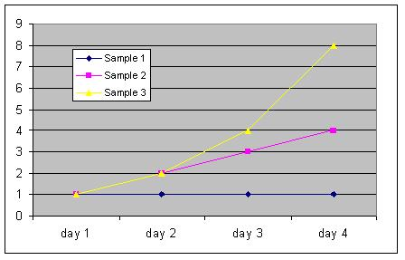
Figure 1. Sample Only

…………………One-page only…………………

