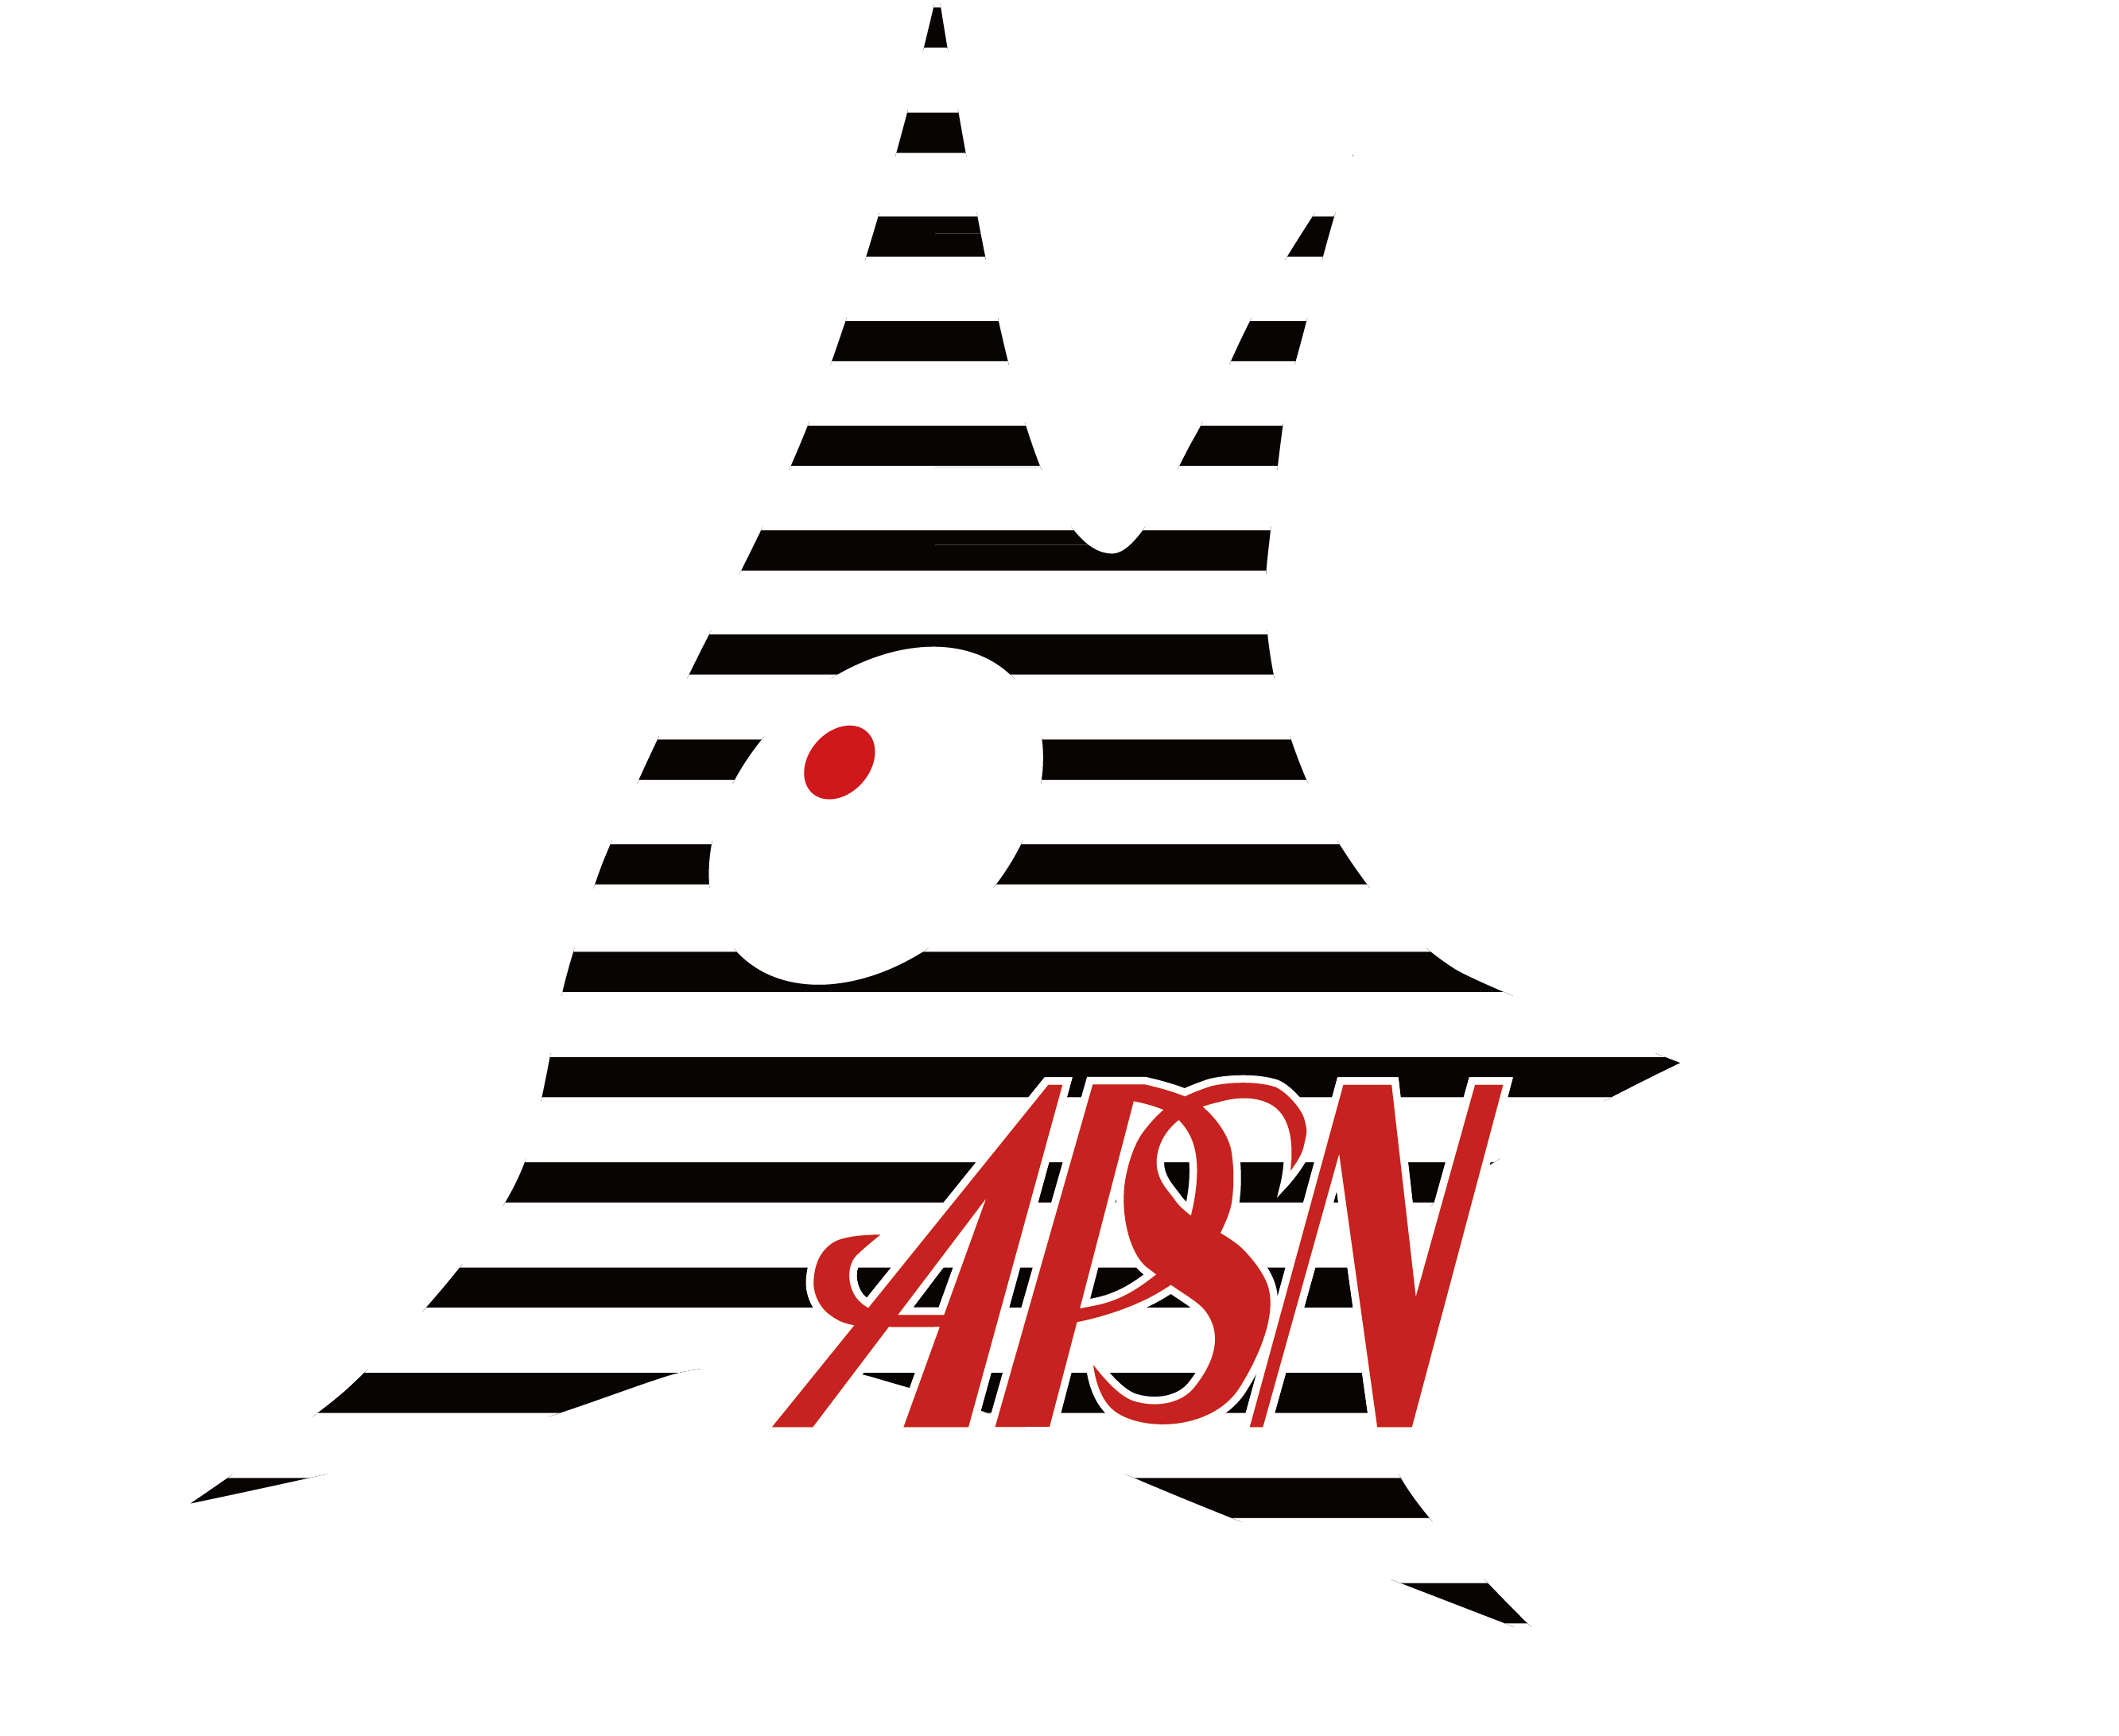
15TH MEETING OF THE
ASIAN-PACIFIC SOCIETY FOR NEUROCHEMISTRY (APSN2018)

MACAU AUGUST 27- 29, 2018

Postgraduate Travel Award Application Form
Organizers:
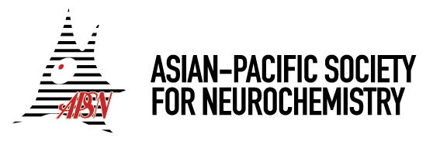

Supporter:

CALL FOR POSTGRADUATE TRAVEL AWARD APPLICATIONS

Closing Date: 20 June 2018

To encourage the participation of young investigators, a number of travel awards will be offered to candidates who are pursuing an advanced degree in neuroscience or neurochemistry in the Asian-Pacific region. Awardees will be selected by the Scientific Program Committee. All awardees are expected to present their research in an oral or poster format. Each of the awardees will receive the following benefits:

Awardees’ benefits:
* a waiver of registration fee.
* an invitation to the APSN2018 Gala Dinner.
* US$300 (international applicants) towards travel and accommodation expenses.

To apply, please submit the following information a single-column Word document to the Scientific Program Committee, Dr. Andrew Jiang, at apsn2018macau@gmail.com.


15th Meeting of APSN 2018

Please attach
one recent photograph
August 27-29, 2018
Macau SAR, China

Application Form

Personal Data
Part A

Name:

(Family Name) (Other names)

Date of birth:
Nationality: __________________________

Place of birth: _________________________ Passport / ID No: ______________________

Sex: Male / Female *

Institution

Correspondence address:

E-mail.:
* delete as appropriat

Copy of Student ID(Please attach here)

Abstract

Title :

Abstract (not more than 350 words):
Academic & Professional Qualifications

Certificate / Qualification obtained | Name of School / Institution | Year obtained | Area of Specialization

Appointments (Present & Past)

Employer | Designation | Department | Start Date | Date Ended

Awards and Honours

Name of awards | Title | Award Authority | Year

List of presentations

Title | Authors | Event | Type of presentation (oral/poster) | Year

List of publications

Title of the article | Authors | Journal  (journal name, volume, issue, page) | Year

Part B

Letter of Recommendation from Department Head

- Title / Name / Post / Institute:

Address / Tel / Fax/ E-mail:

I confirmed that all information given in this application form is true to the best of my knowledge.

Date: Signature:

